Foundation for Virtual and Augmented Reality Systems
Prof. Samit Bhattacharya
Department of Computer Science and Engineering
Indian Institute of Technology, Guwahati
Week – 01
Lecture – 05
Definitions
Hello and welcome to the NPTEL MOOCs course on Foundations for Virtual and Augmented Reality Systems. We are currently discussing definitions as part of lecture 3, and we will continue with that lecture. Previously, we talked about the definition of virtual reality, from which we have identified a few characteristics of VR. Now, in this lecture, we are going to do the same for AR, augmented reality.
So, we will be learning the definition of AR. Also, we will touch upon the definition of MR, or mixed reality, and see the relationship between them. And finally, we will talk about the differences between AR and VR systems. While learning the definition of AR, of course, like VR, we will learn about the defining characteristics of any AR system. Now, like VR, AR is also a combination of two terms: augmented and reality.
We have already seen the definition of reality. Augmented, of course, is when we are adding something to our sense of reality. Now, together, as before, we can go by the dictionary definition of augmented reality. So, what is augmented reality? Like virtual reality, we are using here dictionary definition, Merriam-Webster dictionary, which says that augmented reality is an enhanced version of reality created by the use of technology to overlay digital information on an image of something being viewed through a device. We will see what this definition implies. Just to say it again, an enhanced version of reality.
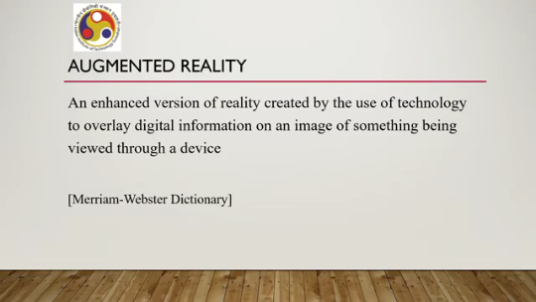
So, we are enhancing reality. This enhanced version is created by the use of technology. Here we are primarily referring to computer technology. Now, how is the enhancement being done? To overlay digital information.
So, we are overlaying digital information on a representation of reality or an image of reality, that is being viewed through a device, that is a technology aid. Now, that is a definition which does not help us much in identifying important characteristics. We can get those characteristics from another systemic definition which was proposed in a paper. At the end, I will refer to that paper.
So, according to the systemic definition which we have partly seen earlier, an AR system should have three characteristics. What are these three characteristics? Number one, it should combine real with virtual; that is, enhancement of reality. Number two is it must be interactive in real time.
So, we are combining some virtual thing with our real world view. And we should be able to interact with that digital content being added to the real world view in real time. So, whatever we do should be reflected immediately. And thirdly, it must be registered in 3D. Now, let us try to break down the definition like we have done in our earlier case; that is, try to identify,
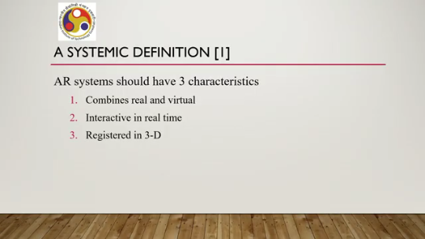
by breaking down the definition, the broad aspects that define an AR system. So, the first thing is reality enhanced by using technology. And this enhancement is overlaying digital information on a real world image. That is the broad aspect, or rather one of the important characteristics of any AR system: a reality that must be enhanced by some technological use.
Here specifically we are referring to computer technology, and this enhancement is basically the overlaying of digital content, digital information on real world images. Now this enhancement must be registered in 3D for seamless mixing with the real world. What it means is that when we are enhancing the digital content on the real world representation viewed through a device, this digital content should not appear randomly at random places. Instead, it should appear at the appropriate place which makes it
apparent, or which lets the user believe, that this particular digital content belongs there. So, essentially the placement must be very appropriate so that it seamlessly mixes with the real world objects. Another important thing that is part of the dictionary definition may not be part of the systemic definition is that whatever we are enhancing, those enhancements must be experienced with sensory organs. So, we should be able to understand what is happening with these digital enhancements.
That is quite obvious; unless we are able to understand that, we will not be able to understand augmented reality or perceive augmented reality. The other important consideration is interaction. So, the system must support interaction for experiencing enhanced reality. So, we are enhancing the reality by adding digital content. A user should be able to interact with that digital content in that enhanced environment, not separately, in that enhanced environment only, so that the user gets the feel of
being in reality at all times. So, going by this breakdown and this understanding, we can summarize AR system characteristics. So, there are broadly four characteristics, as we have discussed previously. Number one, real world enhanced, that means we are enhancing the real world with computer-generated information, digital content.
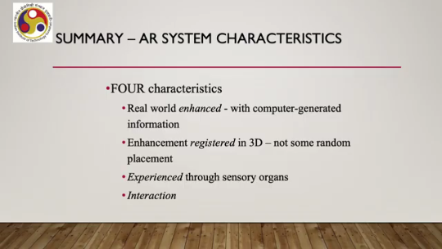
It can be image, video, text, anything. Now, enhancement is registered in 3D. That means whenever this enhancement is being done, it should appear at its appropriate place. It should not appear randomly on the device. Now, this enhancement is experienced through our sensory organs.
This is, of course, one of the obvious parts of the characteristics. And finally, interaction. So the digital enhancement must support interaction by the user. So these are the four characteristics. So for VR we have seen three characteristics, for AR we are seeing four characteristics.
Like VR, we can understand an AR system by checking against these characteristics. So, given any system, we should check the characteristics one by one to see if the system is an AR system or not. Like the previous case, here also, if all four characteristics are satisfied, then only we can call that system an AR or augmented reality system. If it is not the case, if at least one is not satisfied, then we cannot call it an AR system. Now, let us have a quick look at the difference between these two types of systems: VR system and AR system.
Broadly, the difference is that AR alters the ongoing perception of the real world. So, when we are saying that It is an augmented reality system. That means we are referring to the fact that our sense of the real world is being altered. Whereas, when we are saying that we are experiencing a virtual reality system, essentially what we are referring to is that our sense of reality is completely replaced by the virtual environment.
So in the case of AR, we are altering the sense of reality. In the case of VR, we are completely replacing our sense of reality or rather perception of the real world. That is the main difference between these two systems, these two types of systems. Let us try to understand with respect to one example. The scenario is a walkthrough simulation of the inside of a new building.
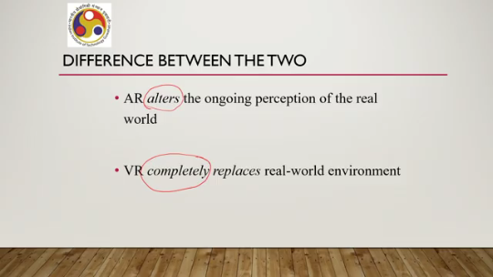
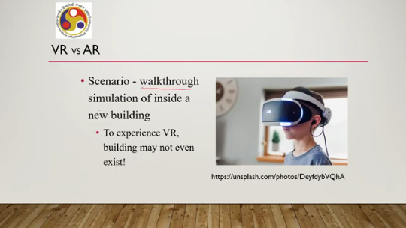
Now, suppose there is a new building coming up. I want to explore the building. Although all parts of the building may not be ready at this moment, I can still explore it in VR. So, VR does not require the building to even exist. Without the existence of a physical object, we can explore different aspects of the object only in VR because we are creating a virtual environment.
It does not require anything related to reality. That is not possible with AR. Now, if I want to explore the same place using AR technology, an AR system, then the first assumption is the building must exist. Then only we can explore the place and see different things. What kind of things can we see?
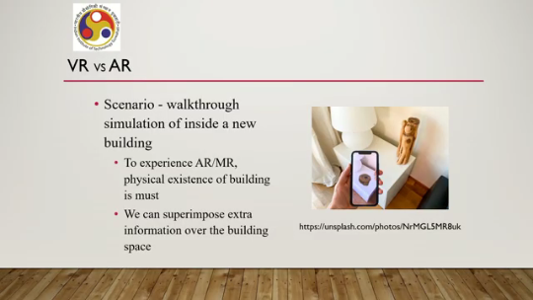
Say if we are using an AR app, we can see the placement of different furniture at different places in a room of an upcoming apartment building. The furniture may not exist. That can appear as digital content on the real-world view of the room, inside the room. As shown in this image, that is one object appearing at this spot where in reality there is nothing here. So, to experience AR or MR, the physical existence of the building is a must; that is not the case with VR. And we can superimpose extra information over the building space, as we have seen.
In our earlier discussion on different AR system categories, we saw that superimposition is one of the categories. It is one of the AR system categories which can be used to decide which furniture to place where or that type of thing. So, I hope this example makes it clear what the difference is between a VR system and an AR system. Now, let us focus a little bit on MR, the third term that we are using. We have so far MR stands for mixed reality.
So, we have so far discussed the definition of augmented reality, and we have discussed the definition of virtual reality. Let us now try to define MR or mixed reality. Mixed reality is also a very popular term nowadays, like VR or AR. The unfortunate fact is according to the literature on this subject, there is no agreement.
I repeat, there is no agreement among practitioners on what exactly MR is. So, there is no agreement on the precise definition of the term MR. Let us see a few variants of the definition that are there, that are being used in practice to develop MR systems or to do research in MR. If we go by the dictionary definition, as we have done before, we can say that mixed reality is a medium consisting of immersive computer-generated environments in which elements of physical and virtual environments are combined. But this definition
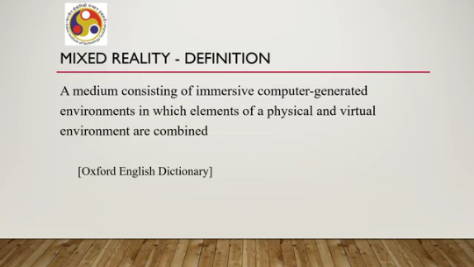
It is not very categorical about how this is different from the definition of, say, VR or AR. So, there is an element of confusion in the dictionary definition. Now, there are a few other definitions available. MR is everything in between. the two extremes in the reality-virtuality continuum.
So, recollect our earlier discussion on this reality-virtuality continuum. On one extreme is the real environment, on the other extreme is the virtual environment. In between, whatever is there, we can call everything to be MR. So, this definition, of course, includes the term AR in the broader definition of MR. So, AR is nothing but MR as per this definition. Sometimes mixed reality is also defined as a combination of AR and VR.
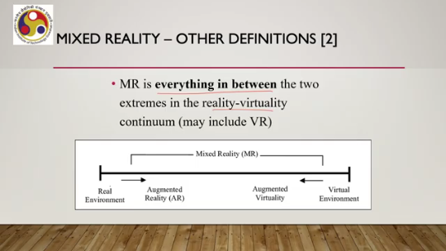
In this case, MR denotes the capability to combine both technologies, AR and VR, in the same app or on the same device. So, this is from the point of view of developers. When we are combining the technologies of AR and the technologies of VR in a single app to give the user some sort of experience, then that type of application we can call MR or mixed reality. Yet another definition is
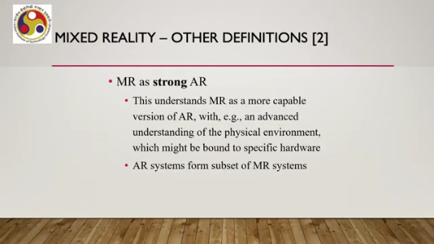
MR is nothing but a strong AR. Now the term 'strong,' of course, is confusing. Now, as per this definition, MR is a more capable version of AR where an advanced understanding of the physical environment is present, which might be bound to specific hardware. A more capable version of AR is the main thing here. So, this is another definition of MR. Finally, many people have also used these two terms interchangeably.
That means, MR is nothing but a synonym for AR. So, there is no confusion with this definition. If we simply assume MR and AR to be the same, whatever is MR is also AR. In both cases, we are viewing reality, which is augmented or enhanced with digital content overlaid on our view of reality and with which we can interact.
So, in other words, MR is simply a different term for AR. These are popular ways of defining MR that we have discussed so far. Now, if we go through all these definitions, we will see that most of the definitions are confusing in nature, and this controversy is not actually required for our purpose here. We do not need to go into the nitty-gritty of each and every definition.
Instead, we can simply ignore the differences between AR and VR that will not affect any discussion we are going to have in this course. So, we will be assuming the same here. In subsequent lectures, we shall use the terms interchangeably. We will assume that MR is nothing but another term for AR. So AR and MR represent the same technology.
With that assumption, we will proceed in subsequent lectures. So in summary, let us quickly recollect what we have covered in this lecture. Here we have learned the definitions of virtual reality and augmented reality, and also talked about various definitions of mixed reality. However, we are assuming that mixed reality is nothing but another term for AR.
So AR and MR refer to the same technology and idea, which is shared by many practitioners in the field, if not all. We will be assuming that for simplicity in our subsequent discussion. Now, based on these definitions, we have identified key characteristics of VR systems and of AR systems. And based on these characteristics, we can easily identify what a VR system is; just check the characteristics. Similarly, we can easily identify what an AR system is just by checking its characteristics.
And also, we have touched upon the main difference between VR and AR systems. To recollect, VR systems are the ones which completely replace our perception of reality, whereas AR systems are the ones which augment or enhance our sense of reality. With that, we have come to the end of this lecture. In the next lecture, we will discuss in brief the historical evolution of these technology areas, these fields. So, the references are here.
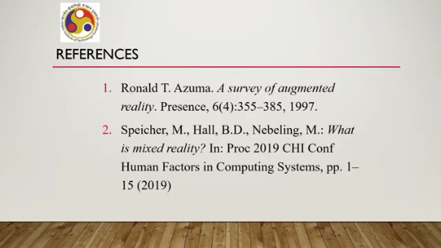
As you can see, I have made use of two references for this topic. Now, the MR definitions you can find in this second reference; different definitions are mentioned, and we have zeroed in on the simplest of them all, that is, AR and MR are the same. The first one is the one from where that systemic definition of AR is taken, that is, the three key characteristics of AR. I recommend that you go through these references for more details. So, that is all for this lecture.
I hope you have understood the concepts and enjoyed the content. In the next lecture, we are going to talk about history, historical evolution. So, looking forward to meeting you all in the next lecture. Thank you. Happy learning.

